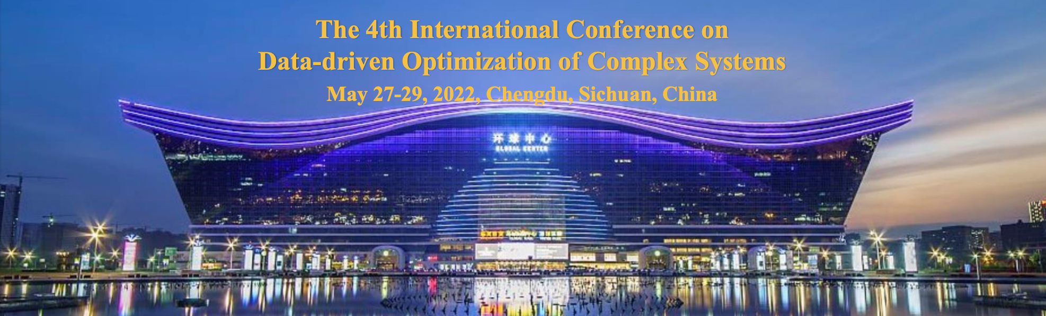
DOCS 2022 Special Session Proposal
Title of the SS: Data-driven Fault Diagnosis and Fault-Tolerant Control Approaches for Complex Industrial Systems

Outline of the Session and Topics:
Outline of the Session

With the development of computing, communication, and control over the past decades, industrial systems are designed to be of large-scale, highly complex, and with unprecedented degree of automation. Novel functionalities and services are powered by intensive interaction with the environment and external systems. To ensure the safety and reliability of critical infrastructures/devices and to achieve satisfactory performance, fault diagnosis and fault-tolerant control (FD/FTC) approaches have been extensively studied. Especially, it is favourable to make use of the colossal amount of available data which contain valuable information about the system operating states. In such context, this Special Session focuses on novel data-driven approaches for fault diagnosis and fault-tolerant control of complex industrial systems. It provides a forum for researchers and industrial engineers to exchange their latest results regarding theoretical outcomes, algorithmic innovations, as well as successful and typical practical applications.

The topics of interest include, but are not limited to:

o Data-driven fault detection, isolation and identification
o Robust FD/FTC approaches against disturbances
o Data-driven artificial intelligence approaches (e.g., for fault classification)
o Performance evaluation with industrial big data
o Plantwide system monitoring and fault diagnosis
o Data-driven FD/FTC design for distributed systems
o Performance-supervised and quality-oriented FD/FTC
o Performance-guaranteed FTC design
o Plug-and-play fault-tolerant controller design
o Practical applications with online/real-time implementation
o Computer vision-based fault-tolerant control and performance recovery

Organizers:

- Dr. Yuchen Jiang received his B.E. degree and Ph.D. degree from the Department of Control Science and Engineering, Harbin Institute of Technology, in 2016 and 2021, respectively. His research interests include data-driven safety and security monitoring, fault diagnosis, fault-tolerant control, and the applications to complex systems such as industrial cyber-physical systems. (yc.jiang2016@foxmail.com)
- Dr. Hongyan Yang received the Ph.D. degree in control science and engineering from the Harbin Institute of Technology, Harbin, China, in 2020. She is currently with the Faculty of Information Technology, Beijing University of Technology, Beijing, China since 2020. Her current research interests include adaptive fuzzy/neural control, fault estimation, fault tolerant control, and Markovian jump systems. (Yanghy@bjut.edu.cn)
- Dr. Yunsong Xu received the B.E. degree in automation and the M.Sc. degree in control science and engineering from Harbin Institute of Technology, Harbin, China, in 2012 and 2014, respectively, and the Ph.D. degree in electrical engineering and information technology from the University of Duisburg-Essen, Duisburg, Germany, in 2018. He is currently with National University of Defense Technology, Changsha, China. His research interests include fault-tolerant control, reinforcement learning, vision-based control systems and cyber-physical systems. (xuyunsong20@nudt.edu.cn)
- Prof. Hao Luo received the B.E. degree in electrical engineering from Xi’an Jiaotong University, Xi’an, China, in 2007, and the M.Sc. and Ph.D. degrees in electrical engineering and information technology from the University of Duisburg-Essen, Duisburg, Germany, in 2012 and 2016, respectively. He is currently a Full Professor with the School of Astronautics, Harbin Institute of Technology, Harbin, China. His research interests include model-based and data-driven fault diagnosis, fault-tolerant systems, and their plug-and-play application on industrial systems. (hao.luo@hit.edu.cn)
- Prof. Shen Yin received the M.Sc. and Ph.D. (Dr.-Ing.) degree from the University of Duisburg-Essen, Germany. He is currently DNV-GL Professor with the Department of Mechanical and Industrial Engineering, Norwegian University of Science and Technology. His research interests include safety, reliability of complicated systems, system and control theory, data-driven and machine learning approaches, applications in large-scale systems and industrial cyber-physical systems. (shen.yin@ntnu.no)

Important Dates (Please refer to the official notifications)
- Paper submission: February 15, 2022
- Notification of acceptance: March 15, 2022
- Camera-ready copy and author registration: April 15, 2022

